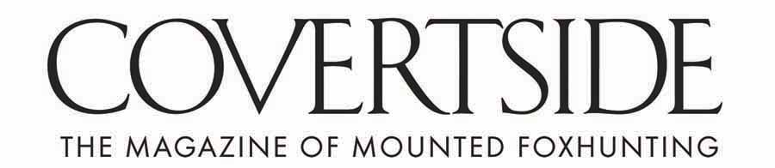
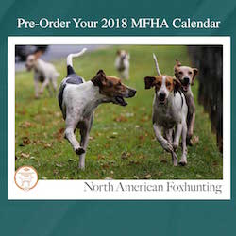

The MFHA North American Foxhunting Calendar 2019
Publish Date: 10/5/2018

$28 - Order today!

Quantity_________

Name_____________________________________

Address____________________________________

___________________________________________

Telephone __________________________________
Order 10 or more and take 10% off!

Email ______________________________________

Payment Method:

___ My check for $_____ is enclosed.
(payable to Masters of Foxhounds Association)
___Please charge my credit card:

Name as it appears on the card: ______________________________________________

Billing address (if different from above) _______________________________________

_______________________________________________________________________

_______________________________________________________________________
Card No. Exp. 3- or 4-digit CVV

Mail this form and payment method to:
Masters of Foxhounds Association
PO Box 363
Millwood, VA 22646

Order online at: www.mfha.com

